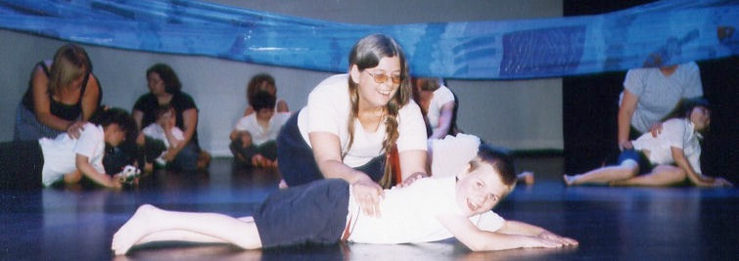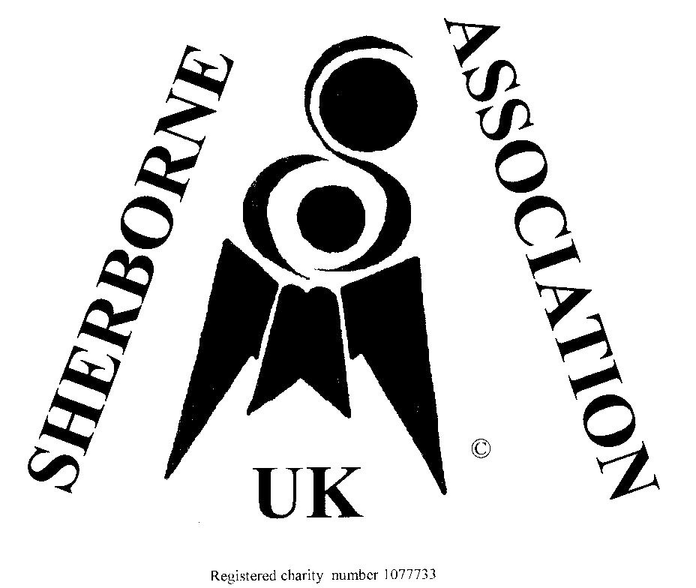

Sherborne Association UK

JOIN NOW !!

**Benefits of using Sherborne**

**Developmental Movement:**

* Develop good self esteem, form positive relationships and improve

emotional and physical literacy.

* Extend and Improve Communication and Creative Expression.
* Build learning power, challenge thinking, increase problem solving.
* Create Pathways for Inclusion; enable differentiated, productive engagement leading to positive achievements.
* Address Provision of Every Child Matters: 5 Outcomes and the National and Foundation Stage Curricula.
* Support professional development, team building, extend

leadership and management expertise.

**What membership gives YOU**

* Newsletter “In Touch” keeps you posted with colleagues’ news,
* Access to professional area of Sherborne web site
* [www.sherborne-association-uk.com](http://www.sherborne-association-uk.com)
* Ongoing research projects, courses, movement days, associated events and ideas.
* Continued professional development through courses and networking.
* International links through ISCO,
* Sherborne is being taught in many countries and many different situations. There may even be an opportunity to twin your school or group…..
* AGM and Movement Day Annually, for renewing and refreshing

ourselves.

Membership Form

**Use this form to apply for new membership**

**or to renew your existing membership.**

**Either way HI & WELCOME!**

**From January 2011 ALL members need to renew NOW and each January. We have two classes of membership:**

**Individual Membership (home or overseas) £25 per year. Student Membership £15 per year.**

**Please print all clearly:**

Name:

Address:

Post Code:

Email:

Tel no:

Please indicate Work / Home / Mobile

**Signed & Dated:**

**Enclose cheque for £25/£15 made payable to Sherborne Association UK & post to:**

**Louisa White: Membership Secretary SDMA UK**

**West Wing Studios, The Point, Leigh Road, Eastleigh,**

**Hampshire SO50 9DE 07530 895404**

Charity No - 1077733